# Summary

## Introduction

Dialogue systems and conversational agents - including chatbots, personal assistants and voice control interfaces - are becoming ubiquitous in modern society. Examples of these include personal assistants on mobile devices, technical support help over telephone lines, as well as online bots selling anything from fashion clothes and cosmetics to legal advice and self-help therapy. However, building intelligent conversational agents remain a major unsolved problem in artificial intelligence research.

## Approach for making a Chatbot

1. **Parsing**: Analyzing the input text and manipulating it by using a number of NLP functions; for example, trees in Python NLTK.
2. **Pattern matching**: Technique that is used in most Chatbots and it is quite common in question-answer systems depending on matching types, such as natural language enquiries, simple statements, or semantic meaning of enquiries
3. **AIML**: Core techniques that are used in common Chatbot design.
4. **Chat Script**: Technique that helps when no matches occur in AIML. It concentrates on the best syntax to build a sensible default answer. It gives a set of functionalities such as variable concepts, facts, and logical and/or.
5. **SQL and relational database**: Technique used recently in Chatbot design in order to make the Chatbot remember previous conversations.
6. **Markov Chain**: Used in Chatbots to build responses that are more applicable probabilistically and, consequently, are more correct. The idea of Markov Chains is that there is a fixed probability of occurrences for each letter or word in the same textual data set.
7. **Language tricks**: these are sentences, phrases, or even paragraphs available in Chatbots in order to add variety to the knowledge base and make it more convincing.
8. **Ontologies**: they are also named semantic networks and are a set of concepts that are interconnected relationally and hierarchically. The aim of using ontologies in a Chatbot is to compute the relation between these concepts, such as synonyms, hyponyms and other relations which are natural language concept names. The interconnection between these concepts can be represented in a graph enabling the computer to search by using particular rules for reasoning.

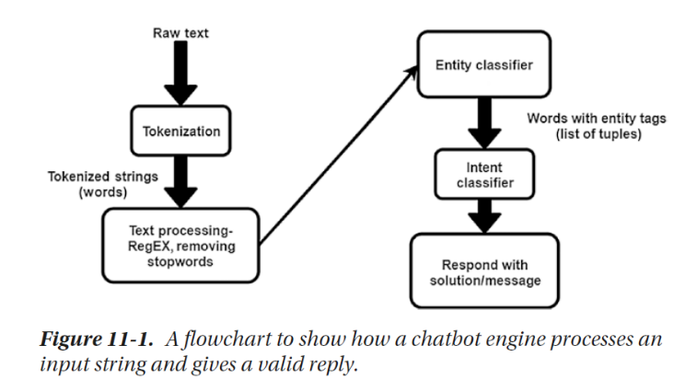

## Components of a Chatbot and Terminologies used

### Intent

When a user interacts with a chatbot, what is his intention to use the chatbot/what is he asking for?

For example, when a user says, “Book a movie ticket,” to a chatbot, we as humans can understand that the user wants to book a movie ticket. This is intent for a bot. It could be named “*book_movie*” intent.

Another example could be when a user says, “I want to order food,” or “Can you help me order food?” These could be named “*order_food*” intent. Likewise, you can define as many intents as you want.

### Entities

Intents have metadata about the intent called “**Entities.**” In the example, “Book a movie ticket,” booking a ticket could be an intent and the entity is “**movie,**” which could have been something else as well, like flight, concert, etc.

You can have general entities labeled for use throughout the intents. Entities could represent as a quantity, count, or volume. Intents can have multiple entities as well.

For example: Order me a shoe of size 8.

There could be two entities here:

Category: Shoe

Size: 8

### Utterances

Utterances are nothing but different forms of the same question/intent your user may show.

• Remember we discussed the switching off the light intent? That was an example of how a user can use different utterances for the same intent.

• It is suggested to have an optimum 10 utterances per intent and a minimum of 5, but this is not restricted.

## Architecture of a Chatbot

The overall chatbot Architecture is shown in Figure.2. Intent classification module identifies the intent of user message. Entity recognition module extracts structured bits of information from the message. The candidate response generator is doing all the domain-specific calculations to process the user request. The response selector just scores all the response candidate and selects a response which should work better for the user.

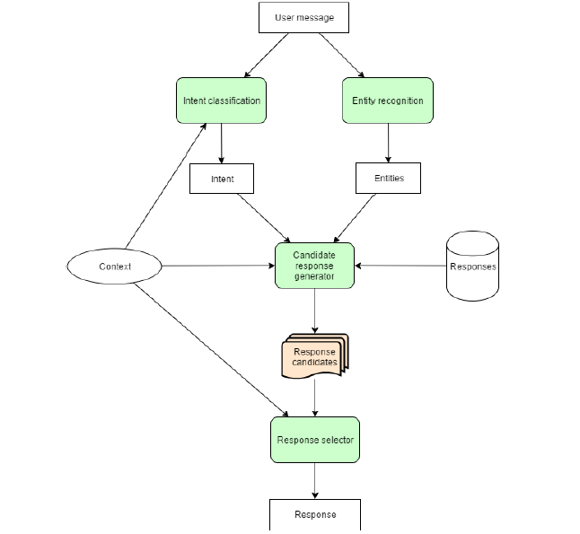

Fig: Chatbot Architecture

## Challenges with Chatbots

### Users way of texting

Different people have their own way of typing a message (short sentences, long sentences, really long sentence in a chat bubble, multiple very short sentences in multiple chat bubble…) So how to understand the user intention.

**Points to discuss**

-When should a bot reply?

-How long should a bot wait to understand human?

-How many chats should a bot club together to understand human response?

### User Language

When it is about talking to a human, it is about talking to individual who is totally unique. Her way of command over language, usage of slang, love of certain words, habit of misspelling certain words, using short forms, using cool words that origin daily, and a list can go on. When you want a chatbot to be talking like a human in a same manner, we have to deal with all of these as well. Natural language processing alone does not help here, understanding at a different level does.

**Points to discuss**

* Should we focus on masses?
* Should we make bot for user segment?
* Will persona creation work and till what level?
* Are we expecting too much from the machine?

### Limitations of NLP

The current state of natural language Processing is not that advanced to tackle everything. The synonyms, extraction of entities has been taken care of but what about mixing of local language, the words and slang being added to the vocabulary at the speed we are not matching with. Though it is involving and you can always amend the level it is right now at, but it takes time. It is a process, and will evolve more and more as the need is arising. Great tools are using it for well for search, tagging, sentiment analysis, and recommendations, so can we use it for chatbots.

The first and foremost challenge of the chatbot is to handle NLP issue by mastering their syntax. If we ask them that " what's the weather?". You will get an answer but what if we ask "Could you check the weather?" you might not get the proper answer. Such type of programming issues falls in natural language processing category which is a key focus for the companies like Facebook, Google with Deep Text and Syntax Net respectively.

**Points of discussion**

* How much time will it take to evolve to an average human level?
* How well will be able to leverage it?
* Amending the code cannot be a never-ending process, a code that learns by self, but when?
* What all can we do till the time it is at the not so smart phase?

### Randomness of being a human

Human beings are beings with emotions. The user behavior is controlled by emotions. You feel different at different instances and it is not permanent and you change your mood easily with right triggers. So, do the way you express yourself in messages.

Mood is a big factor. Your user might want to tell the bot what to do sometimes and then very next moment would want it to recommend. She might want to convince or to be reminded of. So, knowing randomness helps.

**Points of discussion**

* How many cases can we write?
* How to know the user well?
* How effectively can we analyze the user, using user behavioral and data-based triggers?

### Need for more

Your users always want the best experience. If your chat bot is below average, they want it to be average, if it is average, they want it better, better is not it, they want the best. At par with a smartness level of a human. Honestly, if I want to talk with anyone, I want to talk to a person smarter than my caliber and this is what is expected out of chatbots. People want to use chatbots that can help them, that are smart enough for them to relay on. That may fail but what they do, they should do it smartly and in an impressive manner. Improving your chatbot is important.

**Points of discussion**

* Defining a smartness limit!
* How often to iterate your bot to make it smarter?

### Limited Attention Span

User attention span is limited and often users are very distracted, so it is not only that we understand them. Here is where conversational UI is at play. It is more about how can we hook them. So how you respond to a user message is where you grab user’s attention. The more effectively you do the more chances are to be used again. So, writing responses to user queries should be taken very seriously.

**Points of discussion**

* Creativity play how important is it?
* How to push the conversation effectively?

## Recognizing user intents is what is needed

I keep talking to bots, of course to see the current state of chatbots ;) And soon I land at state “Sorry, I could not understand” some handle this creatively I appreciate that. Some will even do web search for my hello or how are you? A chatbot is not a chat bot if it cannot handle a basic hi, hello responses. Your bot can say that this is what I am good at doing but doing a Google search for “Hello” this is not what your users are here for. Thought of putting some screenshots but then I don’t want to discourage anyone. What this chatbot culture to evolve and evolution take time.

**Points of discussion**

* Intents are not limited when it comes to human behavior?
* How well can we map the intents?

## Evaluation

There are a number of different perspectives on how to evaluate chatbot performance. From an information retrieval (IR) perspective, chatbots have specific functions: there are virtual assistants, question-answer and domain-specific bots. Evaluators should ask questions and make requests of the chatbot, evaluating effectiveness by measuring accuracy, precision, recall, and F-score relative to the correct chatbot response.

From a user experience perspective, the goal of the bot is, arguably, to maximize user satisfaction. Evaluators should survey users (typically, measured through questionnaires on platforms such as Amazon Mechanical Turk), who will rank bots based on usability and satisfaction. From a linguistic perspective, bots should approximate speech, and be evaluated by linguistic experts on their ability to generate full, grammatical, and meaningful sentences.

Finally, from an artificial intelligence perspective, the bot that appears most convincingly human (e.g. passes the Turing Test best) is the most effective.

Techniques and Technology

Most recent works focused on applying deep learning models but each of these formulates the problem in aparticular way and uses a different set of features. Most used machine learning models are sequence-to-sequence learning and reinforcement learning.

Seq2seq: Sequence to sequence (seq2seq) learning represents a pattern for using Recurrent Neural Networks (RNN) to tackle complex sequence-to-sequence prediction problems such as machine translation, image captioning, speech recognition text summarization and question-answering.

Currently seq2seq models hold the state- of-the-art performance on chatbot building. These models are trained to map input sequences to output sequences. The length of the input and output sequences can be different and this is the strength of seq2seq models in comparison with other neural learning models. Technically, a seq2seq model is composed of an encoder and a decoder. Artificial intelligence (AI), natural language processing (NLP), and machine learning are chatbot underlying technologies.

## Conclusion

A chatbot is a rising trend and chatbot increases the effectiveness of business by providing a better experience with low cost. A simple chatbot is not a challenging task as compared to complex chatbots and developers should understand and consider the stability, scalability and flexibility issues along with high level of intention on human language.

In short, Chatbot is ecosystem and moving quite fast and with the passage of time new features are added in the existing platform. Recent advancements in the machine learning techniques may able to handle complex conversation issue such as payments correctly.

# Sources

1. Survey on Chatbot Design Techniques in Speech Conversation Systems by Sameera A. Abdul-Kader and Dr. John Woo.
2. Building Chatbots with Python: Using Natural Language Processing and Machine Learning by Sumit Raj.
3. Programming challenges of Chatbot: Current and Future Prospective by AM Rahman, Abdullah Al Mamun and Alma Islam.
4. <https://chatbotslife.com/challenges-with-chatbots-not-just-technical-ecb39612422f>
5. CHATBOT: Architecture, Design, & Development by Jack Cahn.